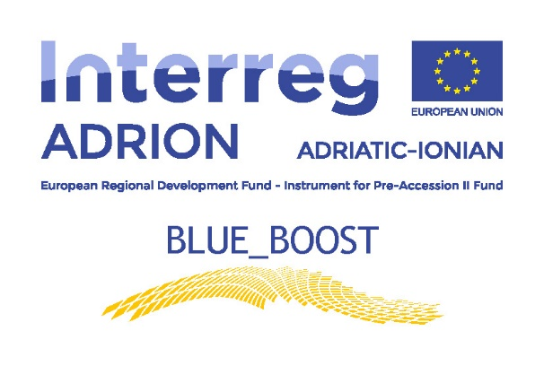
Annex IV

INFORMATION ON PROCESSING OF PERSONAL DATA FOR SCIENTIFIC RESEARCH PURPOSES (ART. 13 REG. UE 2016/679)

Blue_Boost (in the following, “Project”):

Dear applicant,

pursuant to Regulation (EU) 2016/679 and the subsequent national transposing laws (jointly, the "GDPR"), with this privacy information notice we wish to inform you about the processing of your personal data by the partners of the Project.

Aims and data flow of the Project

The project, which aims to make public data of the selected applicants ((in the following, the selected applicants are called “participants”) in order to build a public list of participants to the Cross Field Visit programme and to provide them with travel fiches, is led by the Albanian Development Fund- Department for regional development and University of Camerino (in the following, UNICAM), in collaboration with all Project partners. The characteristics of the project and its methods of implementation are described in the following: the applicant will provide its data within a procedure for the selection of participants to the Cross-Field Visit organised by the Project partners. If selected, the participants will sign an agreement with UNICAM with which it undertakes to participate in the Cross-Field Visit and the related tasks in return for a travel fiche that covers the cost for the participation. Each participant organization will also assume the obligation to write, at the end of the experience, a report on its activities, the competence acquired, the possibility of transfer the same in their own contexts, based on the form provided by UNICAM. The data and information released within the procedure for the selection of participants and through the report can be processed by UNICAM, Project partners and the ADRION Programme through paper and electronic tools for internal analysis and, finally, published on digital platforms. Data can be used to profile the participants, generate travel fiches vouchers and send e-mails to the participants.

Data Controller and Data Protection Officer

The data processing controller is UNICAM and can be contacted at: protocollo@pec.unicam.it.
The UNICAM responsible for data protection can be contacted at: rpd@unicam.it
Purposes of data processing and storage

The processing of participants’ data is carried out for the realization of the scientific purposes of the Project. The Project has been drawn up according to the methodological standards of the related scientific sector and it is deposited at the School of Science and Technology of UNICAM, where it will be kept for five years from the planned conclusion of the research.

Legal basis of data processing

The processing of participants’ personal data is carried out by the owner in the execution of his duties of public interest pursuant to art. 6, paragraph 1, lett. e) of the GDPR. The treatment of particular categories of personal data (sensitive data) is carried out for scientific research purposes pursuant to art. 9, paragraph 2, lett. j) of the GDPR. Category and type of personal data processed. The realization of the Project implies the treatment of the following personal data: Name of the Applicant, Legal Status, Type of Applicant (MSMEs, Professional, Sectoral agency, Interest groups including NGOs, Business support organisation, Higher education & research, International organisation under international law, Regional/Local public authority, Other), Address, Website, E-mail and Phone number, VAT or other national identifying number (if no VAT number is provided), Core activities - NACE code, Description of the products and services offered, Technology applied, Turnover in the last 3 years, Number of employed people, Participation to Clusters, Networks or Flags, Quality Certifications, Previous participation to local, national or international projects, Legal representative name, Legal representative contact (E-mail and Phone number), Participant name, Participant contact (E-mail and Phone number), Role in the applicant organisation

Methods of data processing

Your personal data shall be processed exclusively by the scientific responsible and/or authorized subjects in the realization of the Project. UNICAM, as well as by any Project partner in accordance with the instructions provided by the Albanian Development Fund - Department for regional development, have been appointed to carry out certain tasks or to conduct specific stages relating to the data processing, such as by way of example the allocation, management and maintenance of the electronic databases, or other supporting, instrumental and ancillary activities, such as the transmission of information and/or documents. In this case, the processor will provide sufficient guarantees to meet the requirements set forth by the applicable law provisions governing data processing, including all security-related provisions.

Data storage and retention

The participants’ data collected and processed for the purposes indicated in section “Aims and data flow of the Project” shall be stored and retained during the whole Project duration - unless the participants has submitted a specific and legitimate request for erasure - and at most up to 5 years after the end of the Project.

Motivation of provisioning data

The provision of the participants’ data for the aforementioned research purposes is essential for the development of the Project and does not derive from a regulatory and/or contractual obligation. Failure to provide such data determines the inability to participate in the Project.

Recipients of personal data and transfer of data to Countries abroad

The applicants’ personal data in the unapproved state will not be made visible to the public and will only be visible to UNICAM (in a non-anonymous way) for acceptance. This data will not be disclosed to third parties. Once accepted, the data will be visible to the whole Project Partners and, if needed, to the web through a public list of participants to the Cross Field Visit.

Dissemination of research results

Statistical and/or scientific results can be disseminated (for example through the publication of scientific papers and/or the creation of databases, also with open access methods, participation in conferences, etc.) only in anonymous and/or aggregated way and in any case in ways that do not make the participants’ identifiable.

Rights of the Participant

As an interested party, the participant can ask the data processing controller at any time for the exercise of rights described in the art.15 of GDPR and, in particular, access to their personal data, rectification, integration, deletion, limitation of processing that concerns them or to oppose their processing.
Pursuant to art. 17, paragraph 3, lett. d) the right to cancellation does not exist for data which must be elaborated for the purposes of scientific research if the objectives of the research itself cannot be obtained without them. For the exercise of the aforementioned rights, please contact the Data Controller and / or the Data Protection Manager at the addresses specified in section “Data Controller and Data Protection Officer”. The participant may also propose a complaint to the Guarantor for the protection of personal data.

For information related to the Project, please contact the Scientific Responsible of the Project at the following address: diletta.cacciagrano@unicam.it

The undersigned, taking into account the information received

Pursuant to art. 4, n. 4 GDPR, profiling represents any form of automated processing of personal data consisting in the use of such personal data to evaluate certain personal aspects of a physical person, in particular to analyze or predict aspects concerning professional performance, economic situation, health, personal preferences, interests, reliability, behaviour, location or movement of that physical person.

