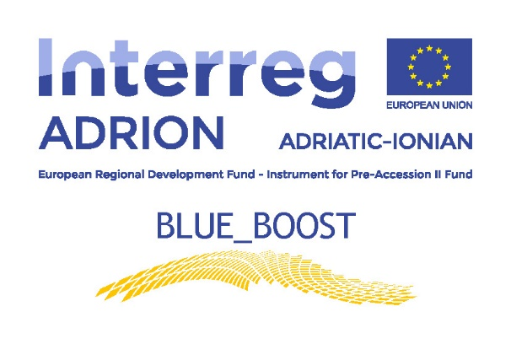

Blue_Boost Transnational Cross-Field Visits

Application Form
for the selection of the participants to the
Blue_Boost Cross-Field Visits programme

APPLICANT PROFILE
Name of the Applicant
Legal Status
Type of Applicant (MSMEs, Professional, Sectoral agency, Interest groups including NGOs, Business support organisation, Higher education & research, International organisation under international law,
Regional/Local public authority, Other)
Address (if the legal seat is not in the Marche Region, please provide also the address of the branch in Marche Region)
Website, E-mail and Phone number
VAT or other national identifying number (if no VAT number is provided)
Core activities - NACE code
Description of the products and services offered
Technology applied
Turnover in the last 3 years
Number of employed people
Participation to Clusters, Networks or Flags
Quality Certifications
Previous participation to local, national or international projects
Legal representative name
Legal representative contact (E-mail and Phone number)
Participant name
Participant contact (E-mail and Phone number
Role in the applicant organisation

MOTIVATIONS AND EXPECTATIONS
Main reasons for participating to the Cross-Field Visit
Main expectations from the participation to the Cross-Field Visit

Place and date  ______________________ | Signature of legal representative _____________________________
I hereby agree for processing the personal information included in this application form strictly for the purposes of this selection and in accordance with the regulation for the protection of personal data D.lgs. 196/2003 - Codice Privacy

Applicant’s Declaration
for the selection of the participants to the
Blue_Boost Cross-Field Visits programme

The undersigned

Surname _____________________________________________________________________________________________

Name _____________________________________________________________________________________________

Born in _____________________________________________ on ________________________

Living in _____________________________________________________________________________________________

Address __________________________________ nr _______ Postal code_________________

Phone number _______________________ Mobile __________________________

e-mail ______________________________________________________________________________________________

in my capacity as the legal representative of

Name of the applicant organisation__________________________________________________________

Address __________________________________ nr _______ Postal code_________________

Phone number _______________________________________________________________________________________

e-mail _____________________________________________________________________________________________

website _____________________________________________________________________________________________

VAT or other national identifying number (if no VAT number is provided)___________________

Require

to be admitted to participation to the Cross-Field Visit in Apulia Region – Italy from 17.07.2018 to 18.07.2018

to this end Declare:

- All information concerning the participation of my organization in the Cross-Field Visit in Apulia Region, as enclosed in the application form, has been verified and it is true and correct;

- As far as the above mentioned Cross-Field Visit and the related tasks are concerned, my organization will be represented by:

Surname _____________________________________________________________________________________________

Name _____________________________________________________________________________________________

Born in _____________________________________________ on ________________________

Living in _____________________________________________________________________________________________

Address __________________________________ nr _______ Postal code_________________

Phone number _______________________ Mobile __________________________

e-mail ______________________________________________________________________________________________

Role in the organization_____________________________________________________________________________

- I give full mandate to (name and surname of the participant) to participate to the above mentioned Cross-Field Visit for representing my organization;
- (name and surname of the participant) have the following level of knowledge of the English Language (mark with an X the level held for each type)

 | Listening and reading | Speaking | Writing
BASE
MEDIUM
ADVANCED

- (name and surname of the participant) has appropriate and valid documents for travelling in Italy (here-to attached) at the date of submission of the application and for the duration of the Cross-Field Visit;
- The undersigned declares to have taken note of the notice/announcement and that, if selected to benefit the Blue_Boost Cross-Field Visits programme, will write at the end of the experience, a report on its activities, the competence acquired, the possibility of transfer the same in their own contexts.

Place and date ______________________ | Signature _____________________________

